Gowtham kumar reddy.M
Reg.No:192572066
DSA0108-ASSIGNMENT CODE AND OUTPUTS
1.Hospital Consultation Billing System
#include <iostream>
#include <string>
using namespace std;
// Function Prototypes
double consultationCharge(double doctorFee);
double consultationCharge(double doctorFee, double specialistFee);
void updateBill(double &bill, double insuranceDiscount);
double addExtraService(double bill, double serviceCharge = 150);
void displayDetails(string patientCategory, double totalBill);
int main()
{ int option;
double doctorFee, specialistFee, insuranceDiscount, bill;
char extraService;
string patientCategory;
cout << "===== HOSPITAL CONSULTATION BILLING SYSTEM =====\n";
cout << "1. Regular Consultation\n";
cout << "2. Specialist Consultation\n";
cout << "Enter Choice: ";
cin >> option;
cout << "Enter Doctor Fee: ";
cin >> doctorFee;
if(option == 1)
{
patientCategory = "Regular Patient";
bill = consultationCharge(doctorFee);
}
else if(option == 2)
{
patientCategory = "Specialist Patient";
cout << "Enter Specialist Fee: ";
cin >> specialistFee;
bill = consultationCharge(doctorFee, specialistFee);
}
else
{
cout << "Invalid Choice!";
return 0;
}
cout << "Enter Insurance Discount (%): ";
cin >> insuranceDiscount;
updateBill(bill, insuranceDiscount);
cout << "Need Additional Service Charge? (Y/N): ";
cin >> extraService;
if(extraService == 'Y' || extraService == 'y')
{
bill = addExtraService(bill);
}
displayDetails(patientCategory, bill);
return 0;
}
// Function Overloading
double consultationCharge(double doctorFee)
{
return doctorFee;
}
double consultationCharge(double doctorFee, double specialistFee)
{
return doctorFee + specialistFee;
}// Call by Reference
void updateBill(double &bill, double insuranceDiscount)
{
bill = bill - (bill * insuranceDiscount / 100);
}
// Default Argument
double addExtraService(double bill, double serviceCharge)
{
return bill + serviceCharge;
}
// Display Function
void displayDetails(string patientCategory, double totalBill)
{
cout << "\n========== BILL DETAILS ==========\n";
cout << "Patient Category : " << patientCategory << endl;
cout << "Total Bill : Rs. " << totalBill << endl;
}
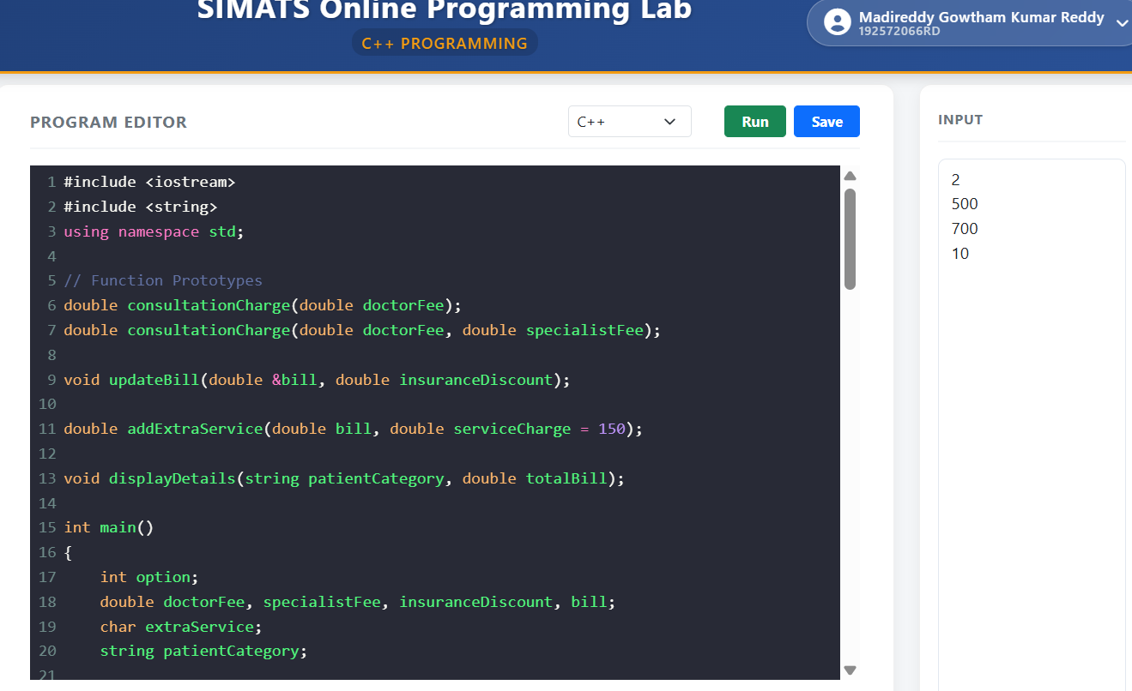

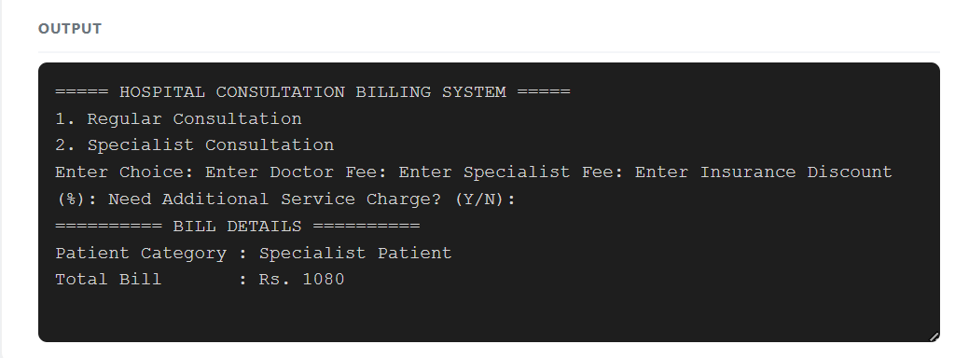
2. Fitness Centre Membership System
#include <iostream>
#include <string>
using namespace std;
class Member
{
private:
int memberID;
string memberName;
string planType;
double fee;
static int totalMembers;
public:
void getMemberDetails();
void choosePlan();
void displayMember();
static void displayTotalMembers();
};
int Member::totalMembers = 0;
void Member::getMemberDetails()
{
cout << "\nEnter Member ID: ";
cin >> memberID;
cin.ignore();
cout << "Enter Member Name: ";
getline(cin, memberName);
choosePlan();
totalMembers++;
}
void Member::choosePlan()
{
int choice;
cout << "\nMembership Plans";
cout << "\n1. Monthly";
cout << "\n2. Quarterly";
cout << "\n3. Annual";
cout << "\nEnter Plan Choice: ";
cin >> choice;
while(choice < 1 || choice > 3)
{
cout << "Invalid Choice! Enter Again: ";
cin >> choice;
}
switch(choice)
{
case 1:
planType = "Monthly";
fee = 1000;
break;

case 2:
planType = "Quarterly";
fee = 2700;
break;

case 3:
planType = "Annual";
fee = 10000;
break;
}
}

void Member::displayMember()
{
cout << "\n----------------------------";
cout << "\nMember ID : " << memberID;
cout << "\nMember Name : " << memberName;
cout << "\nPlan Type : " << planType;
cout << "\nMembership Fee : Rs. " << fee;
cout << "\n----------------------------\n";
}

void Member::displayTotalMembers()
{
cout << "\nTotal Active Members : " << totalMembers << endl;
}
int main()
{
int n;
cout << "===== GYM MEMBERSHIP MANAGEMENT SYSTEM =====\n";
cout << "Enter Number of Members: ";
cin >> n;
Member gym[20];
for(int i = 0; i < n; i++)
{
cout << "\nEnter Details of Member " << i + 1 << endl;
gym[i].getMemberDetails();
}
cout << "\n========== MEMBER DETAILS ==========\n";
for(int i = 0; i < n; i++)
{
gym[i].displayMember();
}
Member::displayTotalMembers();
return 0;
}
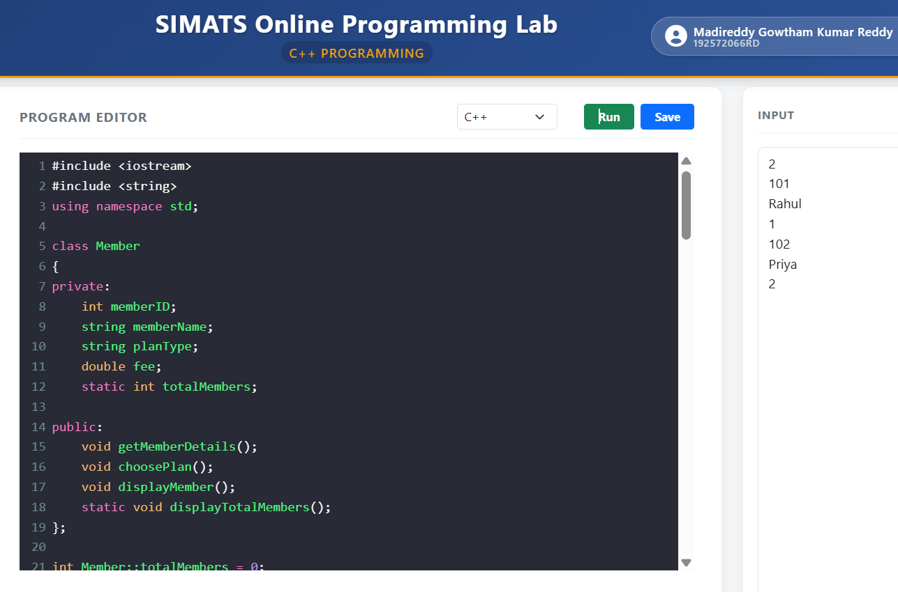
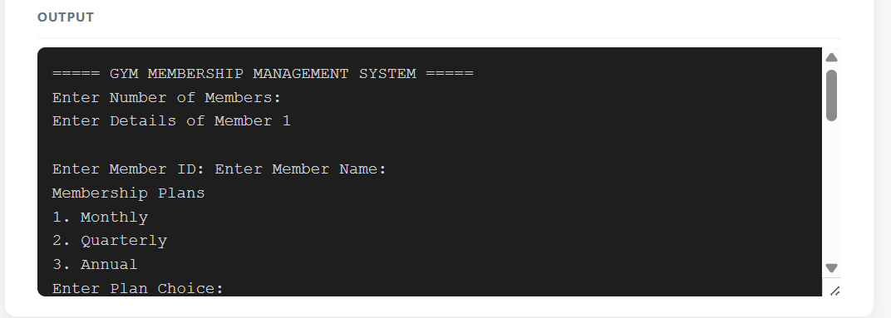
3. Loan Repayment System
#include <iostream>
using namespace std;

// Function Prototypes
double calculateEMI(double loan, int years, double rate = 8.5);
inline double simpleInterest(double loan, double rate, int years);
void applySubsidy(double &amount, double subsidy);

int main()
{
double loan, emi, interest, totalPay, subsidy;

cout << "LOAN REPAYMENT SYSTEM\n";

cout << "Enter Loan Amount: ";
cin >> loan;

int years;
cout << "Enter Loan Period (Years): ";
cin >> years;

// Default interest rate = 8.5%
emi = calculateEMI(loan, years);

interest = simpleInterest(loan, 8.5, years);

totalPay = loan + interest;

cout << "Enter Subsidy Amount: ";
cin >> subsidy;
applySubsidy(totalPay, subsidy);

cout << "\n----- LOAN DETAILS -----";
cout << "\nLoan Amount : Rs. " << loan;
cout << "\nInterest : Rs. " << interest;
cout << "\nEMI (Per Year) : Rs. " << emi;
cout << "\nAmount Payable : Rs. " << totalPay;

return 0;
}

// EMI Function
double calculateEMI(double loan, int years, double rate)
{
double interest = (loan * rate * years) / 100;
return (loan + interest) / years;
}
// Inline Function
inline double simpleInterest(double loan, double rate, int years)
{
return (loan * rate * years) / 100;
}
// Call by Reference
void applySubsidy(double &amount, double subsidy)
{
amount = amount - subsidy;
}

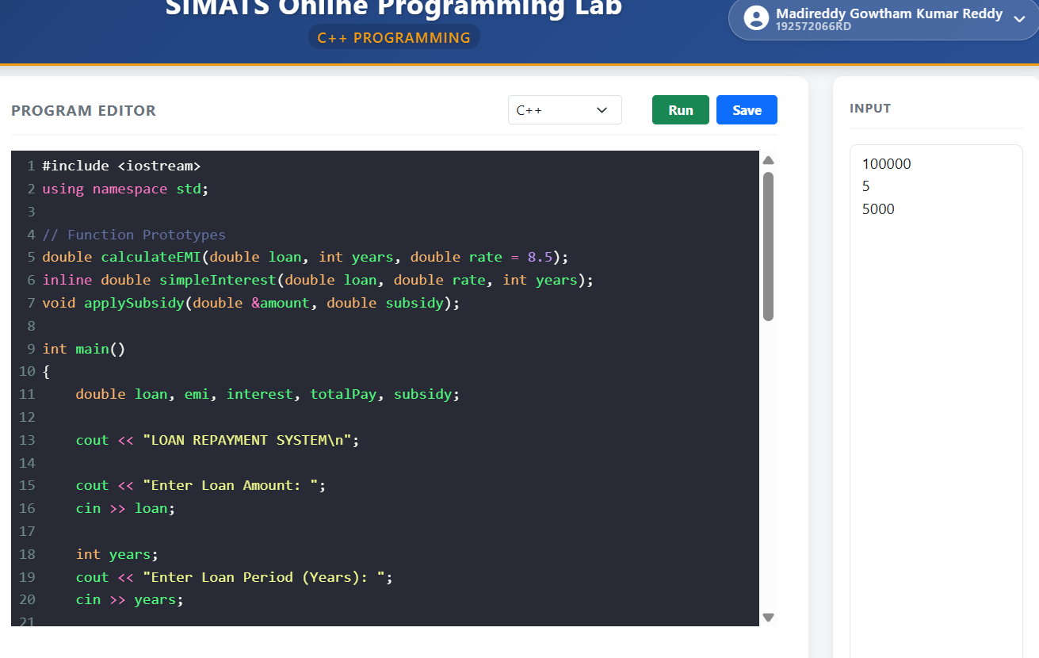
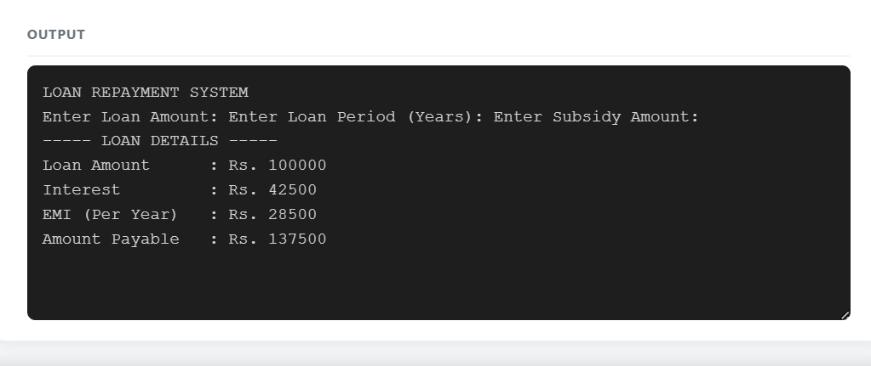
4. Parcel Charge Management System
#include <iostream>
#include <string>
using namespace std;

class Parcel
{
private:
string type;
float weight, distance;

public:
void input();
void calculate();
};

void Parcel::input()
{
cout << "Enter Parcel Type: ";
cin >> type;

cout << "Enter Weight (kg): ";
cin >> weight;

cout << "Enter Distance (km): ";
cin >> distance;
}
void Parcel::calculate()
{
float charge;
charge = weight * 20 + distance * 5;

cout << "\nParcel Type : " << type;
cout << "\nWeight : " << weight << " kg";
cout << "\nDistance : " << distance << " km";
cout << "\nTotal Charge: Rs. " << charge;
}
int main()
{
Parcel p;
cout << "PARCEL CHARGE MANAGEMENT SYSTEM\n";
p.input();
p.calculate();
return 0;
}
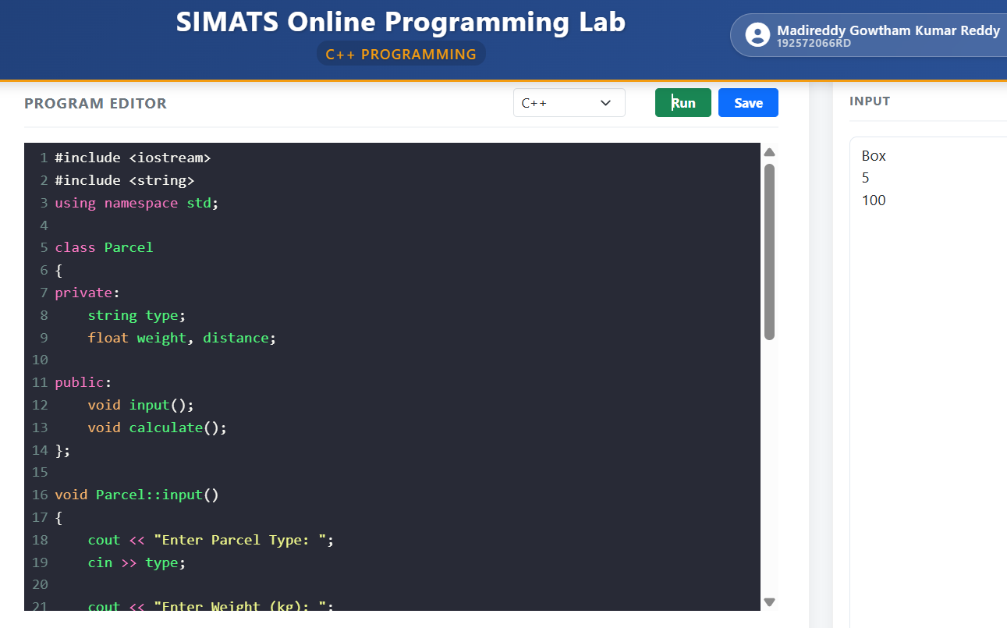
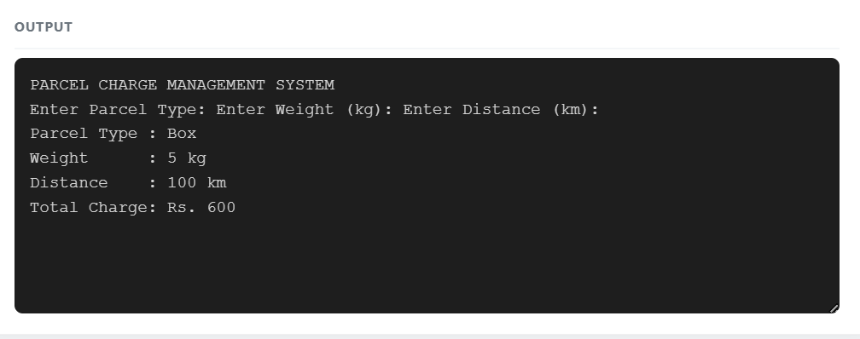
5. Water Billing System
#include <iostream>
#include <string>
using namespace std;

class Consumer
{
private:
int id;
string type;
float liters;

public:
void input();
void calculate();
};

void Consumer::input()
{
cout << "Enter Consumer ID: ";
cin >> id;

cout << "Enter Consumer Type (Domestic/Commercial): ";
cin >> type;

cout << "Enter Water Consumption (Liters): ";
cin >> liters;
}
void Consumer::calculate()
{
float bill;
if(type == "Domestic")
bill = liters * 2;
else
bill = liters * 4;
cout << "\nConsumer ID : " << id;
cout << "\nType : " << type;
cout << "\nWater Used : " << liters << " Liters";
cout << "\nWater Bill : Rs. " << bill;
}

int main()
{
Consumer c;

cout << "WATER BILLING SYSTEM\n";

c.input();
c.calculate();

return 0;
}
